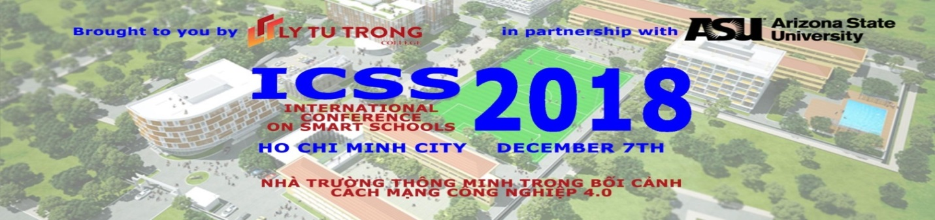
ICSS 2018
SMART SCHOOLS IN THE CONTEXT OF THE INDUSTRY REVOLUTION 4.0

Ly Tu Trong College of Ho Chi Minh is proud to present the International Conference on SMART SCHOOLS 2018, best known as ICSS. Save the date for this upcoming December 7, 2018 and travel to HCMC, Vietnam, to experience interactive plenary sessions, panel discussions and Exhibition.
Location: Ly Tu Trong College of Ho Chi Minh City, Vietnam
Date: Friday, December 7th, 2018
MC: Dr. Phuong Nguyen, Vietnam Country Director, Arizona State University

ime | Activity | Presenter
7.30 - 8.45 | Arrival of the Participants  Tour of Exhibition Booths  Tea and Coffee | MC: Dr. Nguyen Thi Thanh Phuong, Country Director, ASURO, USA
8.45 - 9.00 | Welcome Performances
9.00 - 9.20 | Introduction of Guests  Welcome Message by Meritorious Teacher Pham Huu Loc, Rector, Ly Tu Trong College, HCMC  Welcome Remarks by Mr. Jeffrey S. Goss, Arizona State University  Remarks by Directorate of Vocational Education and Training  Remarks by Director of HCMC Department of Science and Technology | MC: Dr. Nguyen Thi Thanh Phuong, Country Director, ASURO, USA  - Meritorious Teacher Pham Huu Loc, Rector Ly Tu Trong College, HCMC  -Mr. Jeffrey S. Goss, Associate Vice Provost, Arizona State University  - Directorate of Vocational Education and Training of HCMC  - Director of HCMC Department of Science and Technology
9.20 - 9.50 | Keynote Presentation 1  Building the smart connected campus through public-private partnerships | Mr. John Rome, Deputy CIO , Arizona State University, USA
9.50 - 10.20 | Keynote Presentation 2  Teaching with augmented and virtual reality in the 21st century | Dr. Jolanda G. Tromp, Director of Center for Visualization & Simulation Center, Duy Tan University
10.20 - 10.40 | Keynote Presentation 3 | Mr. Degeling Bas, Managing Director of KONE Viet Nam, KONE Corporation
10.40 - 11.05 | Group Photo and Tea Break
11.05 - 11.35 | PANEL DISCUSSION  Development Strategy/solution of Smart Schools in the context of the industry revolution 4.0  Tertiary education of Vietnam and industrial revolution 4.0  EcoStruxture solution for building  Intergrating Display Technology in Education  Classroom smart solutions | Panel Moderator:  - Prof. Dr. Nguyen Loc, Vice Rector of Nguyen Tat Thanh University  -Felicitas Huong Friedrich, CSR Delegate and Education Manager for Schneider Electric  -Erik Tanuwidjaja, Product and Marketing Lead, CE Display SAMSUNG VINA ELECTRONICS Co., Ltd.  - Nguyễn Anh Dũng, Business Developement Manage, Bosch Company
11.35 - 12.00 | Tour of Exhibition Booths | Block B
12.00 - 13.00 | Networking Lunch at Ly Tu Trong College | Area:
13.30 - 14.00 | Keynote Presentation 4  Soft Skills and the Future of Education and the Workplace | Dr. Jim Garrison, Founder and President of Ubiquity University, California
14.00 - 14.30 | Keynote Presentation 5  E-learning in Education 4.0 in Technical Vocational Education; the do'and the dont's | Mr. John J. M. Vlaar, Founder & Chief Vision Officer Electude
14.30 - 14.50 | Keynote Presentation 6  Developing high quality human resources in context of Industrial Revolution 4.0 | Mr. Aru David, Country Director, Mekong Region, Asia Society for Social Improvement and Sustainable Transformation (ASSIST)
14:50 - 15.5 | Coffee Break and Tour of Exhibition Booths and Posters | Block B
15.5 - 16.15 | PANEL DISCUSSION  Development conpetencies for learners in Smart Schools in the context of the industry revolution 4.0  The role and mission of technical colleges in delivering a high quality workforce in the industrial revolution 4.0)  Solutions for developing the digital pedagogy based on the blended learning at the institutions of vocational education  eLearning solutions of Swiss Logitech  Smart library solution - an essential of Smart education | Session Moderator:  Assoc. Prof. Dr. Tran Khanh Duc,  Ha Noi University of Science and Technology  -Assoc. Prof. Dr. Tran Khanh Duc,  Ha Noi University of Science and Technology  - Assoc. Prof. Dr. Bui Van Hong, Dean of Institute, Technology and Education University of HCMC  Nguyen Huynh Thy Khoa, Long Vu Company  Dao Ngoc Hoang Giang, Sao Mai Group
16.30 - 17.00 | Closing Remarks  - Meritorious Teacher Pham Huu Loc, Rector, Ly Tu Trong College, Ho Chi Minh City  - Director of HCMC Department of Science and Technology  Awarding gifts and certificates for presenters | + Meritorious Teacher Pham Huu Loc, Rector, Ly Tu Trong College, Ho Chi Minh City  + Mr. Jeffrey S. Goss, Associate Vice Provost, Arizona State University  + HCMC Department of Science and Technology Representative  + Sponsors Representative: OCB Bank, LONG VU Company, iEG COMPANY, KONE Company, BOSCH Company, Sao Mai Group.
17.00 – 17.30 | Tour of Exhibition Booths  Tour of Smart Academy Center | Block B
17.30 – 18.30 | For VIP guests


